**Using Containers to Build and Deploy Scalable APIs in the Cloud**

February 16, 2016

Strong Loopback framework

* IBM acquired loopback.io
* Raymond Camden, (raymondcamden.com, @raymondcamden)
* Earlier development focused on App server because clients were stupid
* Now the clients are tremendously more powerful than what they used to be. Servers needs to do a lot less – just provide the data, rendering is with Client.
* API servers in 2016 are much smaller, simpler and more of an API provider

Components of a Modern App server

* Since Node.js is very lightweight
  + You would need to write your own or use one of the existing libraries
* Express is a web framework in Node.js
  + Very minimal web framework
  + On /getCats do so and so
  + Makes it easy to load a class
* It allows you to define a model
* Laser focused, define a model and from there a REST API
* Real system ORM system built into it
* Demo

Creating an application

slc <application name>

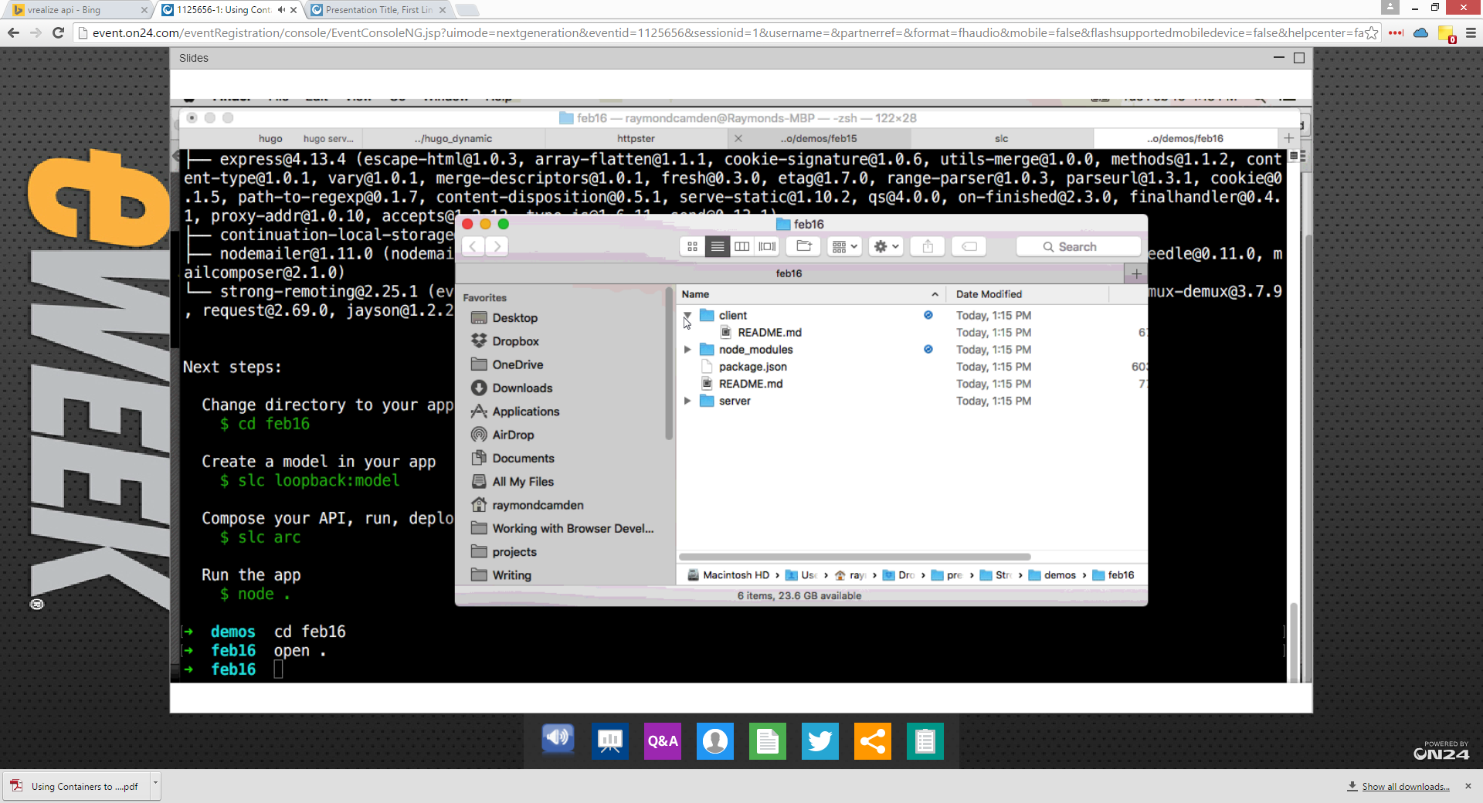

It creates server and client applications

Creating a model

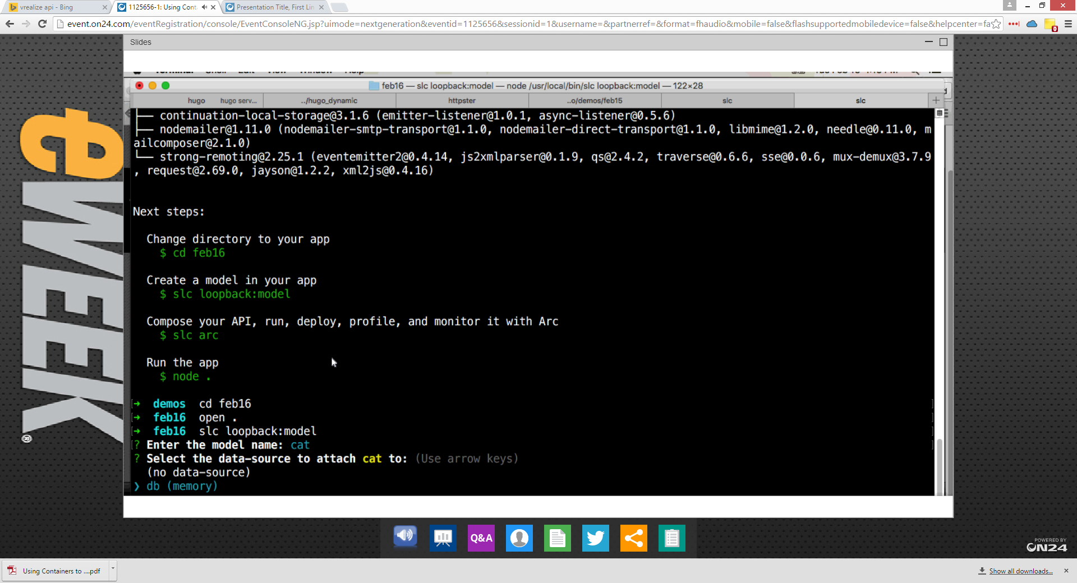

* Loopback works with a variety of data-sources and in-memory is the easiest to work with

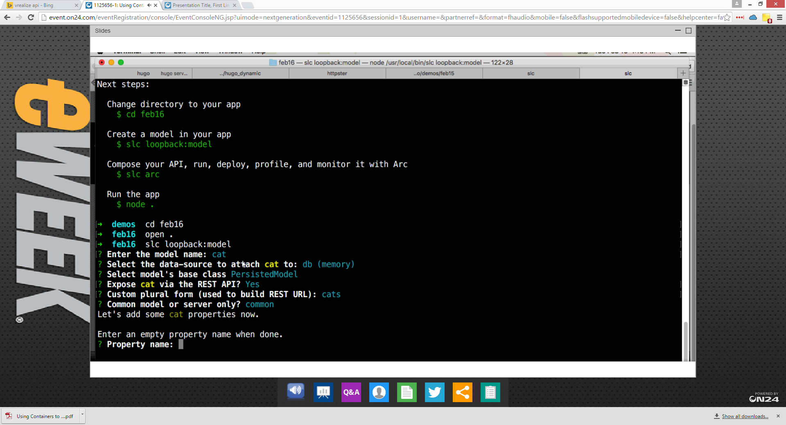

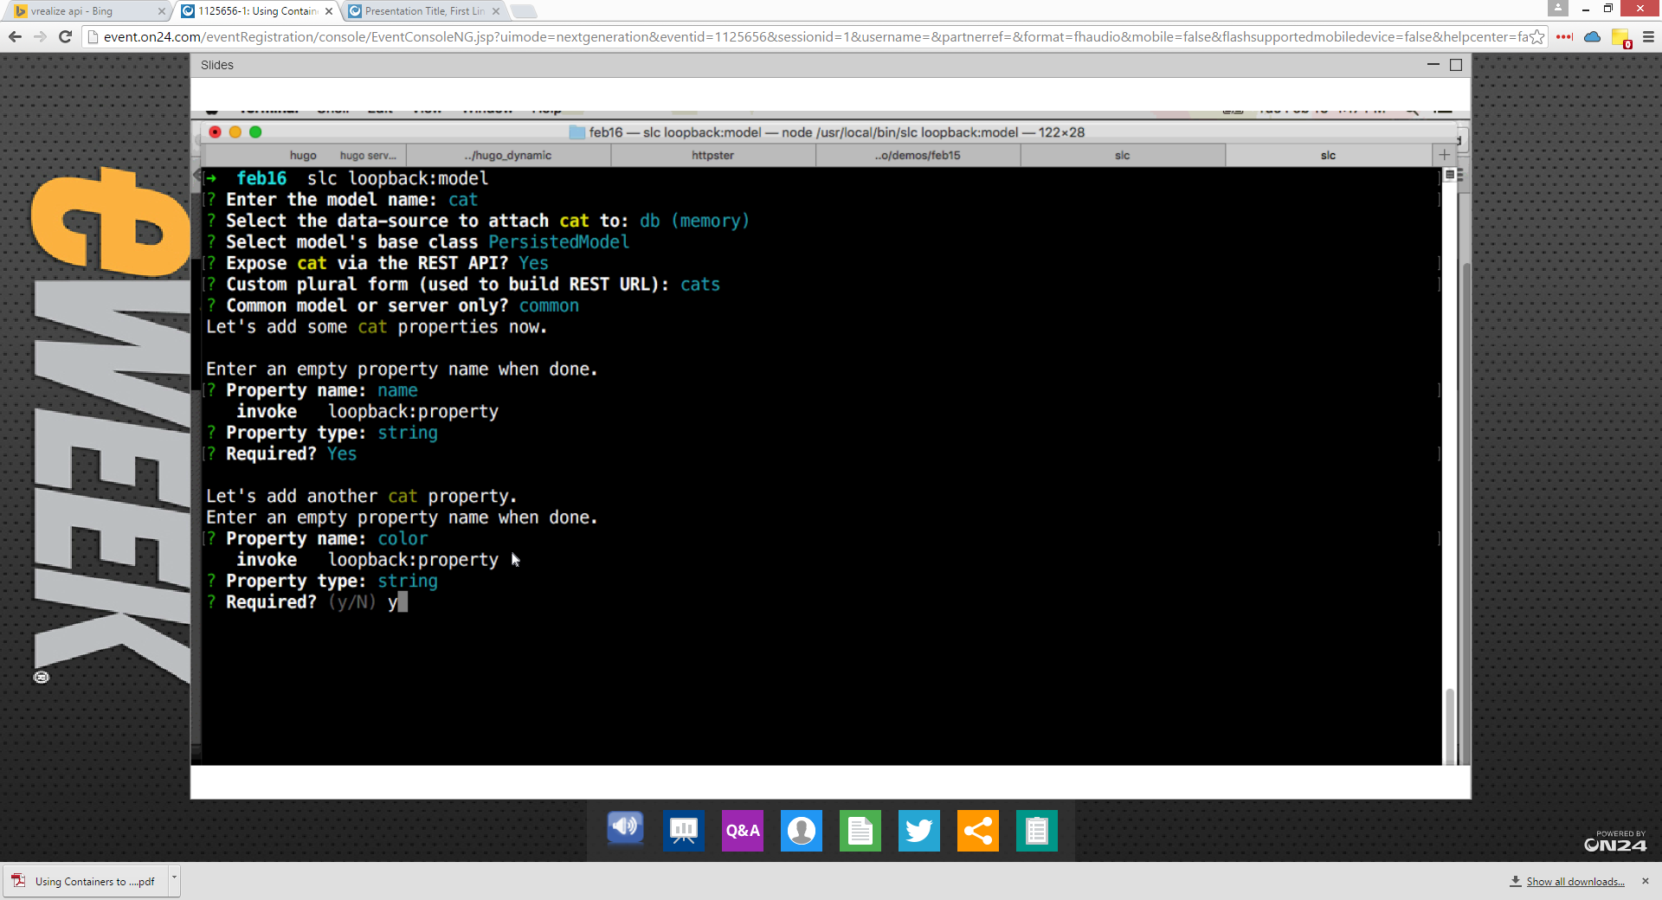

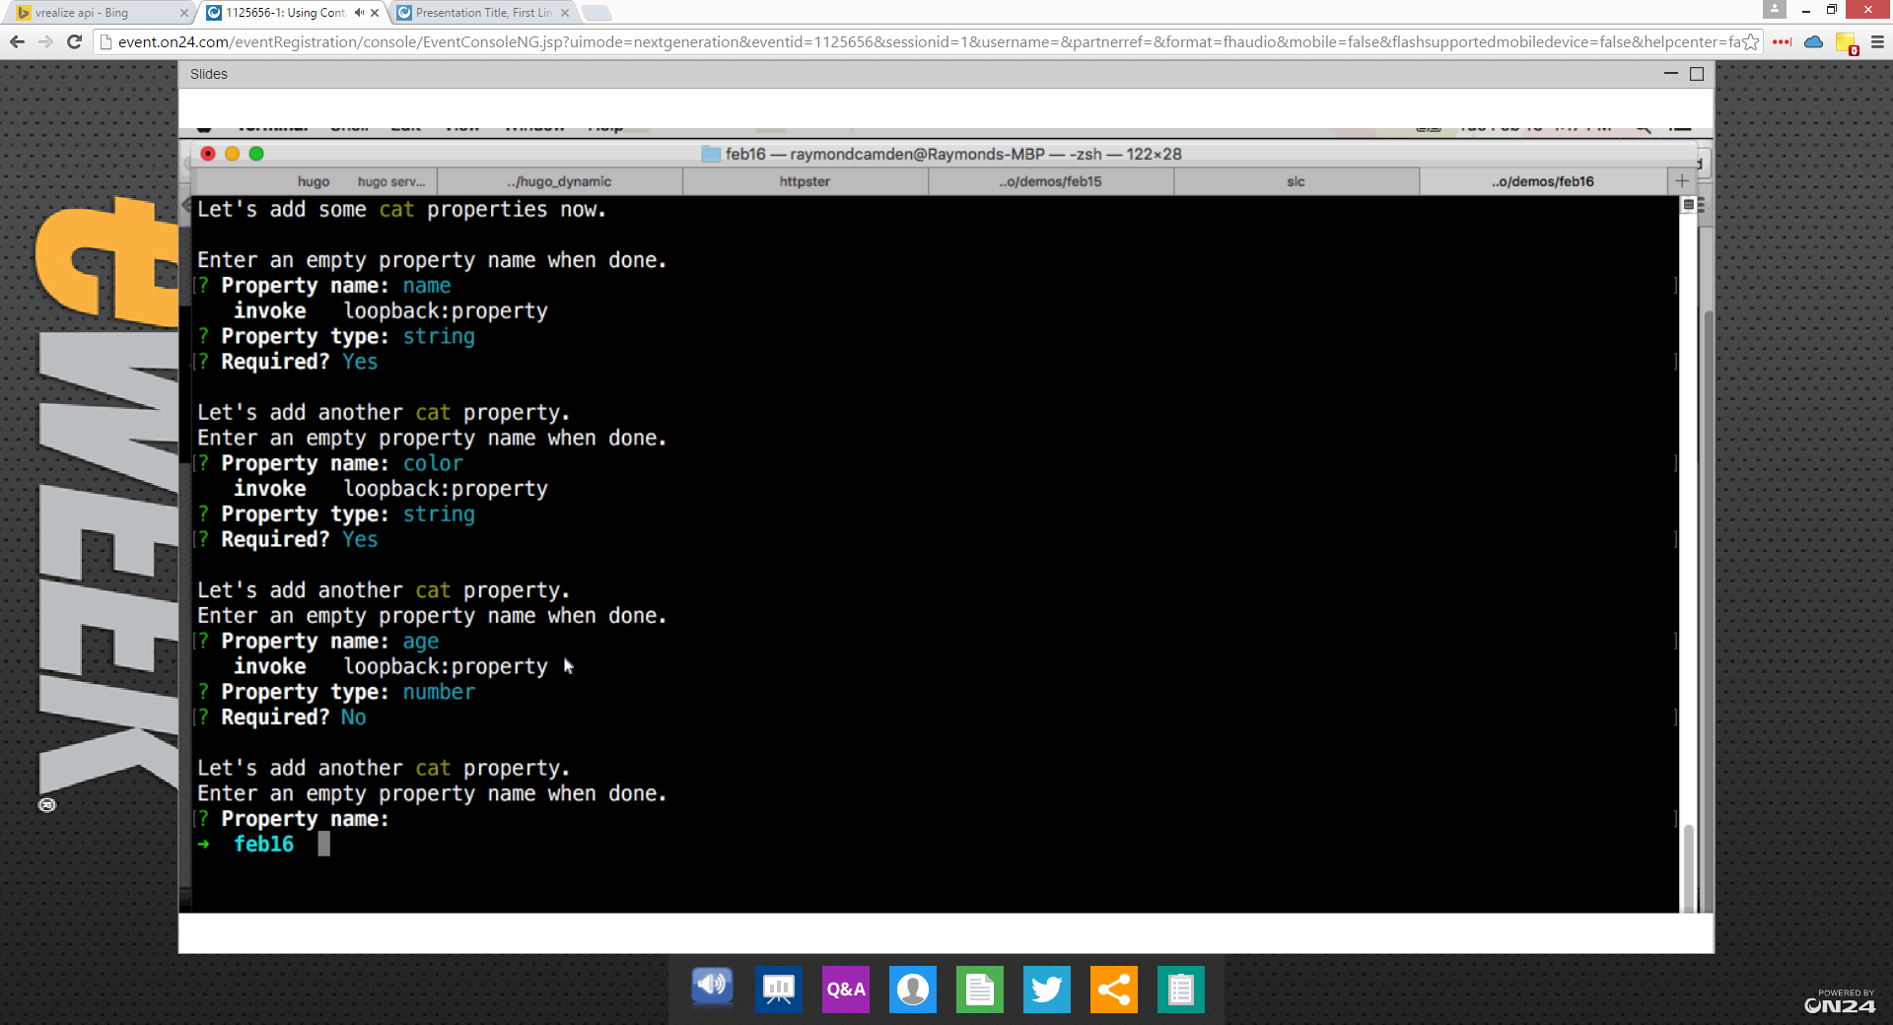

* Defined a few properties of the model
  + Name
  + Color
  + Age

And now working to see if it works

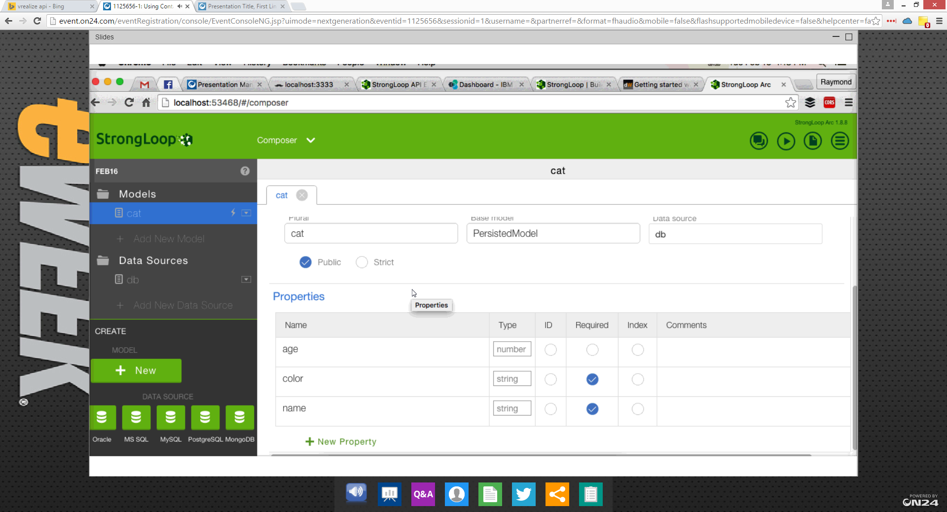

* You can use UI to create/modify models.
* API server

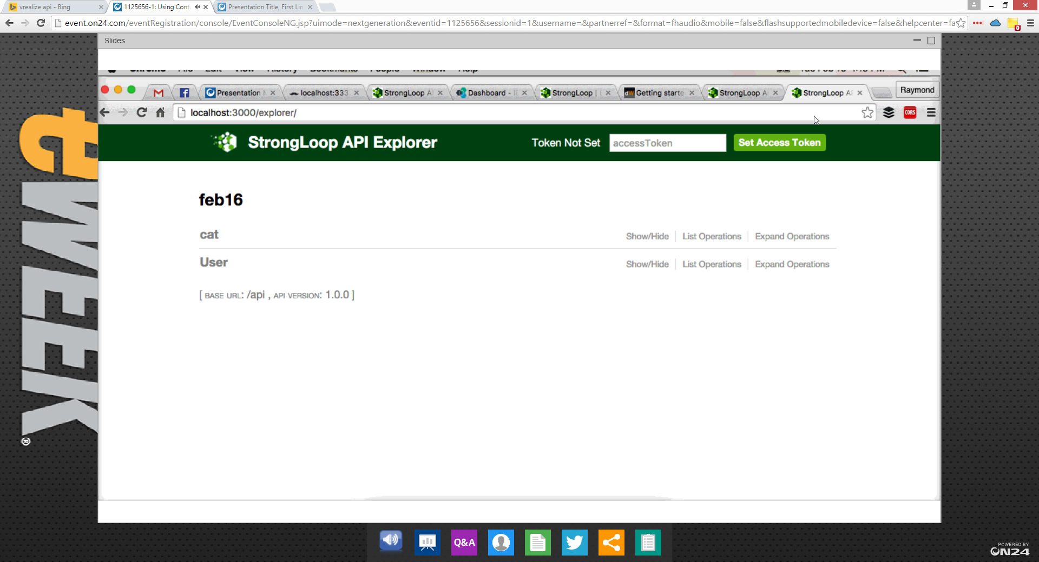

* Automatic API documentation system
* Fully interactive – Swagger UI type

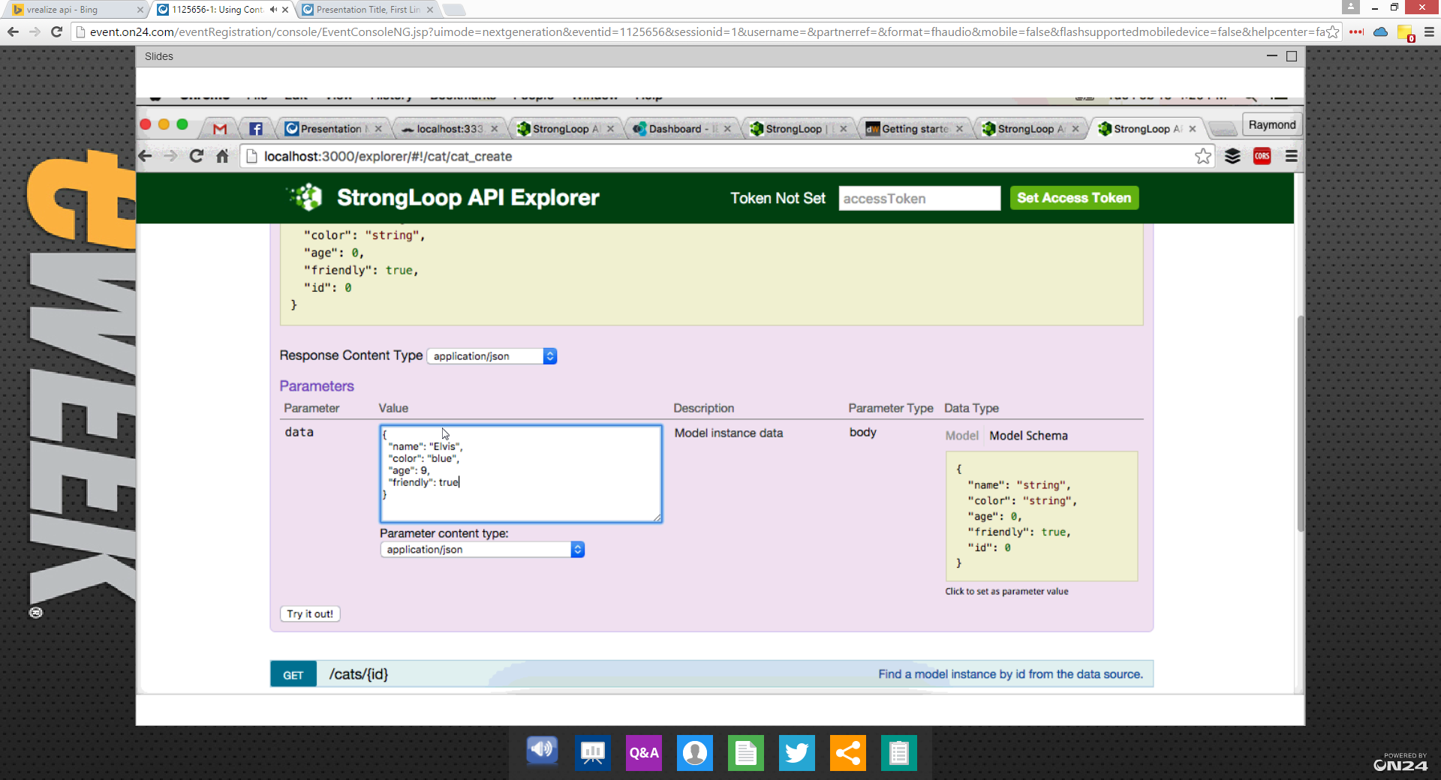

Can actually run the API to create users.

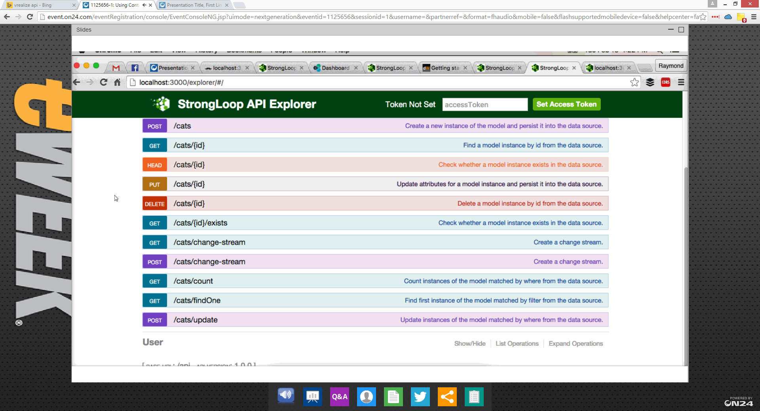

* Defining new APIs – <some> file needs to be modified and new APIs can be exposed.

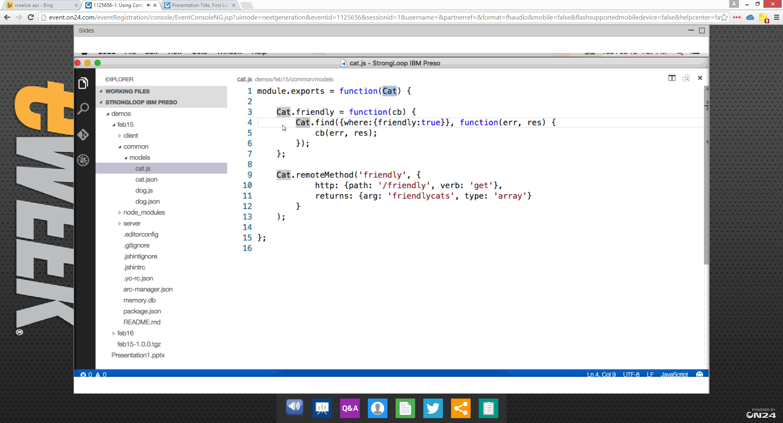

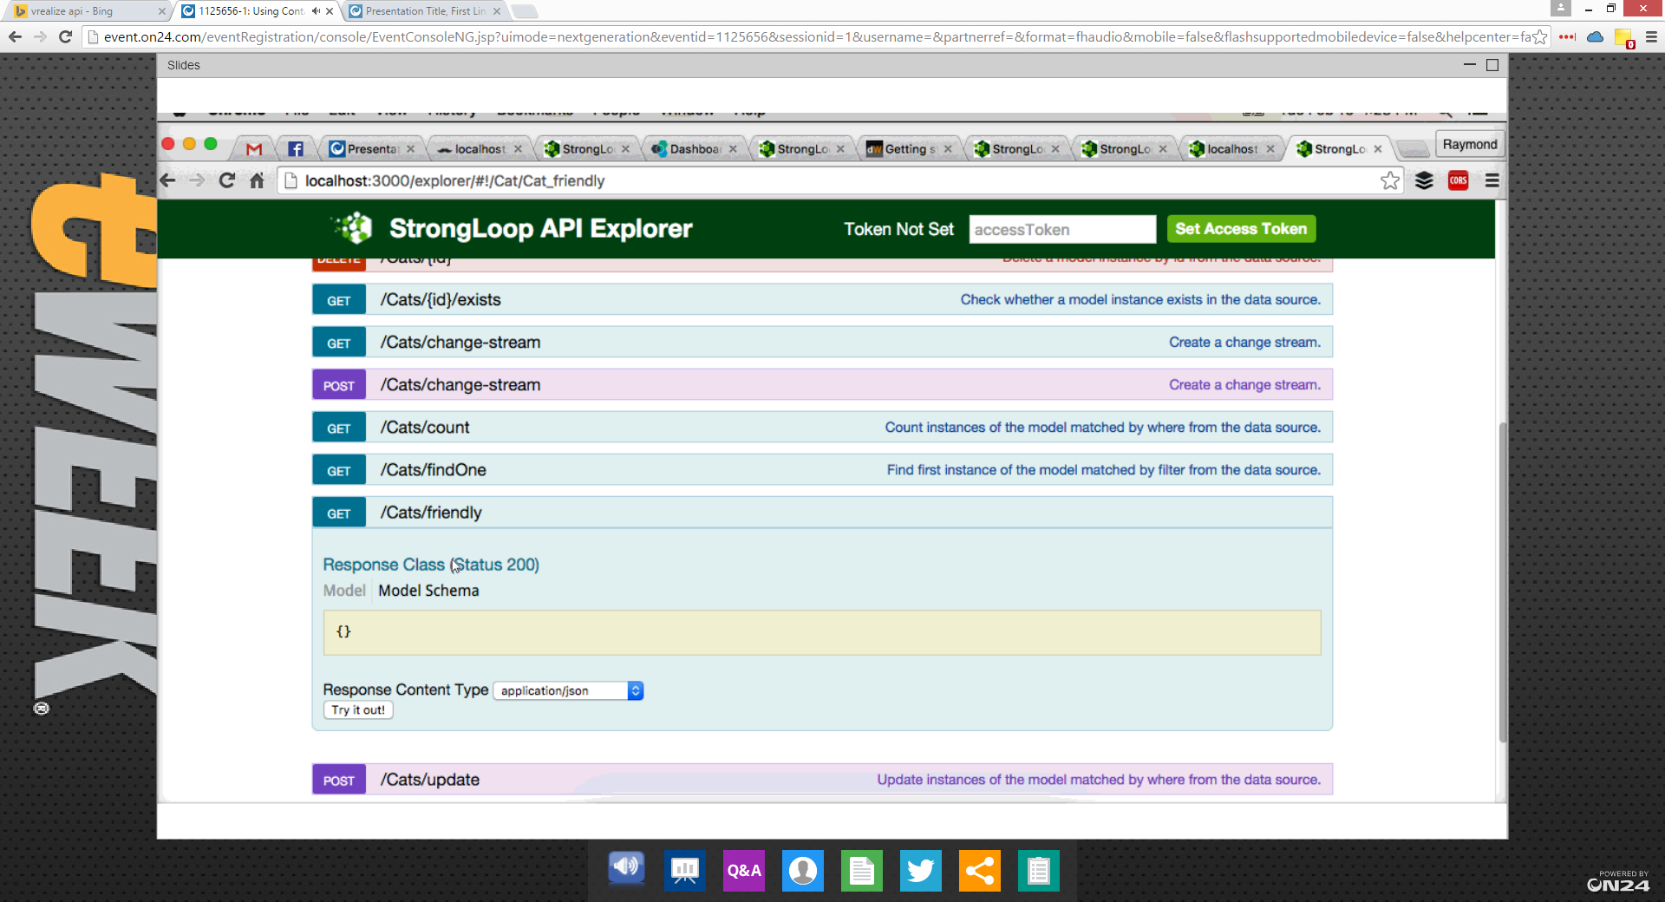

JQuery client

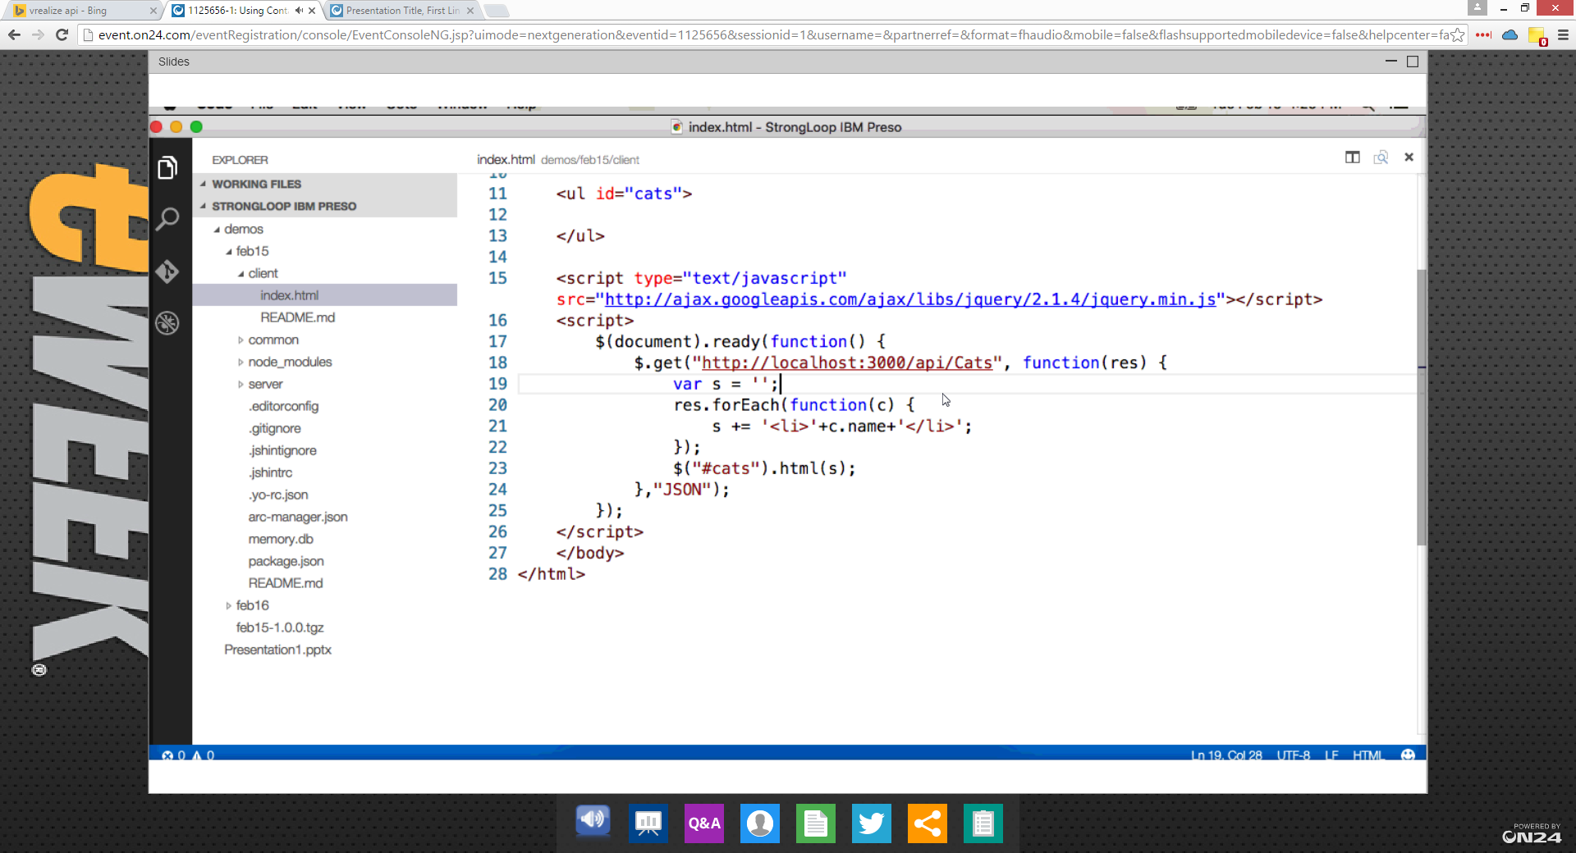

Deploying

* Multiple options – slide 21
* When you are deploying in Bluemix, you get access to Watson
* You can try out Bluemix for free

Delploying in containers

* Sign up in Bluemix, go to containers. Select StrongLoop container
* When you are testing you can only use 2 free public IPs
* Once you created that your container is up an running

StrongLoop Process Manager

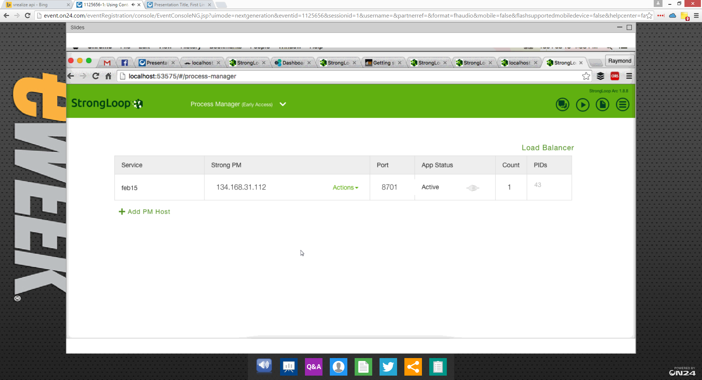

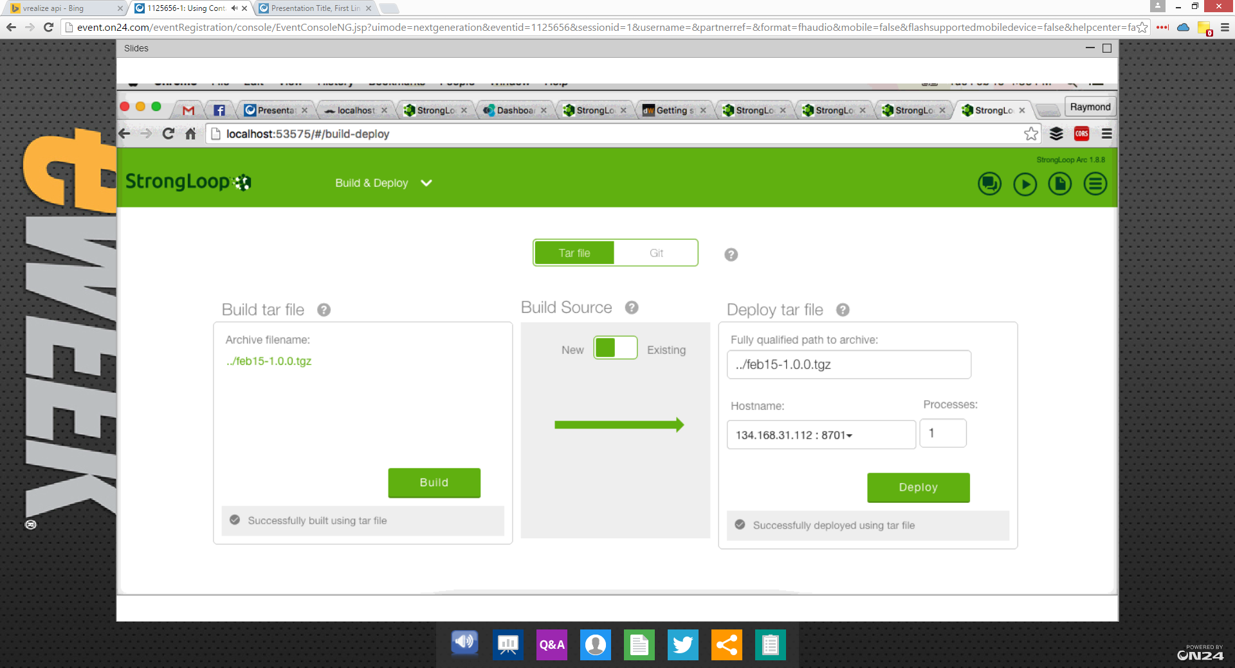

* LoopBack and StrongLoop built on proven technology
* Get from nothing to a full site within a few mins
* Node.js 🡪 Express 🡪 StrongLoop
* BlueMix + Containers – easy to use